**Tugas II Mata Kuliah Etika Pelayanan**

**Sabtu, 19 September 2020**

**Nama** : Nadya Catur Wardani

**NIM** : 071911611028

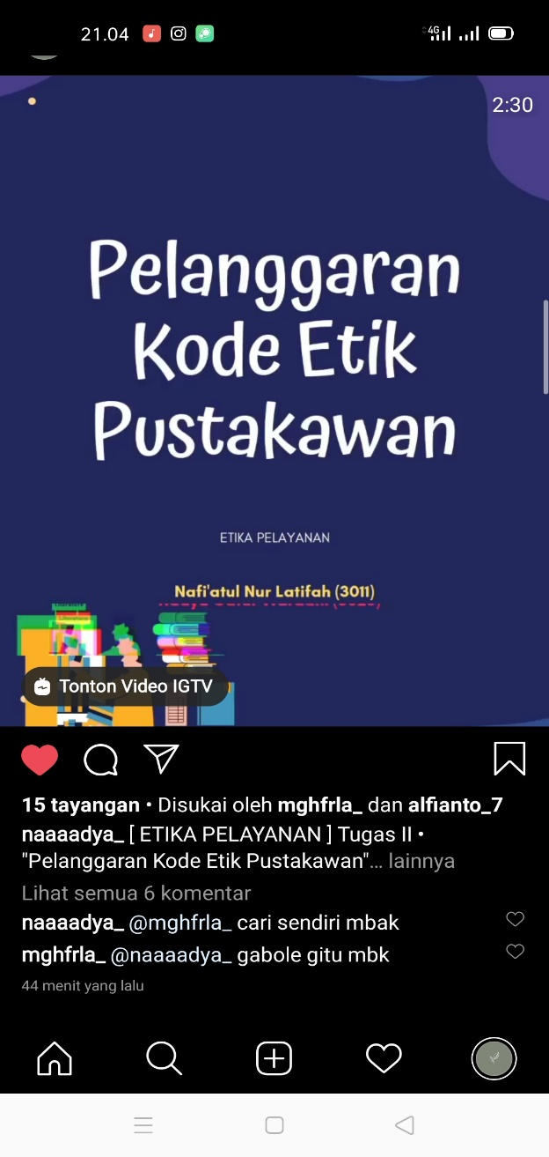

**Judul :** Tugas 2 tentang kode etik pustakawan

**Link Postingan :** <https://www.instagram.com/tv/CFUcxQTlQ9w/?igshid=199yo3wg9eygn>